




AcademiBalance: An AI-Driven Faculty Workload & Time Allocation

Project Domain
Excel, Power BI with Copilot

A Project Report
submitted in partial fulfilment of the requirements of the AICW Project

by:



Faculty Name
Dr. PRIYA. A

Faculty Email
priya@brindavancollege.com
Guide
R. Uma Maheswari

Institution:
Brindavan College

Year - 2026
ACKNOWLEDGEMENT

First and foremost, I thank the Almighty for giving me the strength, health, and opportunity to successfully complete this project.

I would like to express my sincere gratitude to everyone who has supported me, directly and indirectly, in the successful completion of this project on the AcademiBalance faculty workload dashboard and semester planning simulation.

I am deeply indebted to my supervisor, R. Uma Maheswari, for her patient guidance, insightful suggestions, and continuous encouragement at every stage of this work. Her timely feedback, critical questions, and confidence in my ideas helped me refine the research problem, design the metrics such as CAH and SALI, and translate them into a practical decision-support tool.

I also wish to thank the Edunet Foundation, Microsoft, LinkedIn, and SAP for offering the AICW fellowship, the structured learning modules, and access to AI-enabled tools that made it possible to experiment with Power BI, Copilot-based narratives, and other emerging technologies in accounting and workload analytics.

My heartfelt thanks are due to my institution, Brindavan College, Bengaluru, for providing the necessary infrastructure, academic environment, and administrative support, and to the faculty members and Heads of Department who shared their experiences of workload allocation, which inspired the design of the dashboard and simulation scenarios.

Finally, I am grateful to my family and friends for their constant motivation, understanding, and moral support during the entire duration of this project.

ABSTRACT OF THE PROJECT

This project is part of the AICW (Artificial Intelligence in the Contemporary World) Fellowship Program, a collaborative initiative by Edunet Foundation in partnership with Microsoft, LinkedIn, and SAP. The fellowship aims to equip participants with practical skills in Artificial Intelligence, data analytics, and business intelligence tools through hands-on problem-solving projects.

The project, titled “AcademiBalance: An AI-Driven Faculty Workload and Time Allocation Assistant,” addresses the challenge of achieving transparent and equitable faculty workload allocation in a multi-programme arts and science college. In many institutions, teaching, laboratory work, committee duties, and other responsibilities are captured in fragmented spreadsheets and emails, making it difficult for Heads of Department to see who is overloaded, who has spare capacity, and whether allocations are fair.

Using a simulated dataset of 70 faculty members across B.Com, BBA, BBA Aviation, BCA, B.Sc, and Languages, the project introduces three core metrics: Total Workload Hours (TWH), Complexity-Adjusted Hours (CAH), and Student-Adjusted Load Index (SALI). Data is prepared in Microsoft Excel and modelled in Power BI to build an interactive dashboard with KPI cards, programme-wise charts, faculty-wise tables, and a semester planning simulation module. Microsoft Copilot is used to generate narrative summaries of workload patterns, while Microsoft Forms and Power Automate are configured as a low-maintenance pipeline for workload updates and dashboard refresh. In addition, a prototype chatbot layer is envisaged to allow users to ask natural-language questions about workload metrics, overload status, and programme-wise comparisons, further improving accessibility for non-technical stakeholders.

The results show that complexity- and student-adjusted metrics reveal hidden workload inequities that are not visible from contact hours alone and support evidence-based redistribution of courses before timetables are finalised. Overall, AcademiBalance demonstrates a practical, AI-assisted approach—combining dashboards, narrative explanations, workflow automation, and chatbot-based interaction—that typical colleges can adapt to make faculty workload management more transparent, equitable, and data-informed.

TABLE OF CONTENTS
Abstract of the Project
List of Figures
List of Tables
Chapter 1 — Introduction
1.1 Problem Statement
1.2 Motivation
1.3 Objectives
1.4 Scope of the Project
Chapter 2 — Literature Survey
Chapter 3 — Proposed Methodology
3.1 System Design
3.2 Modules / Components Used
3.3 Data Flow Diagram (DFD)
3.4 Advantages
3.5 Requirement Specification
Chapter 4 — Implementation and Results
4.1 Data Cleaning Results
4.2 Visualization / Output Results
4.3 AI Tool Integration Results
4.4 Chatbot Integration Results
4.5 Statistical Validation of Workload Metrics
Chapter 5 — Discussion and Conclusion
References
Appendices

LIST OF FIGURES
Figure No. | Figure Title / Description | Page No.
Figure 3.1 | System architecture of AcademiBalance | 16
Figure 3.2 | Context Level Data Flow Diagram (Level 0) | 18
Figure 3.3 | Level-1 Data Flow Diagram for AcademiBalance | 19
Figure 4.1 | Cleaned faculty workload dataset | 22
Figure 4.2 | AcademiBalance main dashboard view | 23
Figure 4.3 | Average SALI by programme | 24
Figure 4.4 | Selected faculty detail dialog showing workload metrics and status | 26
Figure 4.5 | Example AI-generated workload summary | 26
Figure 4.6 | Chatbot answering workload-related questions in the AcademiBalance system | 27

LIST OF TABLES

Table No. | Table Title / Description | Page No.
Table 4.1 | Cleaned Faculty Workload Dataset Structure | 21
Table 4.2 | Overall Workload Metrics (n = 70) | 22
Table 4.3 | Programme-Wise Average Adjusted Workload | 23
Table 4.4 | Sample Faculty Workload Classification Records | 25
Table 4.5 | Statistical Test Results for Workload Metrics
Table 5.1 | SALI-Based Workload Classification | 28

CHAPTER 1
Introduction
This project, titled AcademiBalance: An AI-Driven Faculty Workload & Time Allocation Assistant Using Excel, Power BI and Copilot, is developed under the Artificial Intelligence in the Contemporary World (AICW) Fellowship Program coordinated by Edunet Foundation (Edunet Foundation, 2026). The fellowship encourages participants to design practical, AI-enabled solutions across domains such as data analytics, business intelligence, healthcare analytics, content generation, and AI-assisted reporting using contemporary tools like Microsoft Excel, Microsoft Power BI, and Microsoft Copilot (Microsoft Corporation, n.d.-a; Microsoft Corporation, n.d.-b; Microsoft Corporation, n.d.-c). Within this framework, AcademiBalance focuses on the persistent challenge of achieving transparent and equitable faculty workload allocation in a multi-programme arts and science college (Fitzpatrick & Mehalik, 2016; Mushabe et al., 2022).

In many higher education institutions, faculty teaching loads, laboratory duties, committee responsibilities, mentoring, and administrative tasks are still captured through fragmented Excel files, email threads, and paper registers rather than through an integrated workload system (Fitzpatrick & Mehalik, 2016; Mostert & van der Merwe, 2016). This fragmented recording makes it difficult for Heads of Department and Principals to obtain a single, reliable view of how work is distributed across individuals and departments, or to answer basic questions such as who is overloaded, who has spare capacity, and whether responsibilities are being shared fairly (Mushabe et al., 2022; Mostert & van der Merwe, 2016). When questions about workload fairness arise, administrators often have to rely on partial or outdated information instead of robust, data-driven evidence (Karthikeyan & Suresh, 2023).

Traditional workload statements used in such contexts are typically based on raw contact hours and treat all teaching hours as if they required the same level of effort, regardless of programme complexity, class size, curriculum design, or assessment intensity (Fitzpatrick & Mehalik, 2016; Mushabe et al., 2022). As a result, a faculty member teaching a large, high-complexity programme such as BBA Aviation Management or B.Com with demanding assessments and regulatory requirements can appear to carry the same “14 hours” as a colleague handling a smaller, lower-complexity language course, even though the real effort and time burden are very different (Fitzpatrick & Mehalik, 2016; Karthikeyan & Suresh, 2023). Visiting and adjunct faculty, who shoulder a significant proportion of teaching in many arts and science colleges, may not be consistently represented in formal workload dashboards or summary reports, further distorting the institutional picture of teaching capacity and distribution (Mushabe et al., 2022; Karthikeyan & Suresh, 2023).

Research on faculty workload modelling has highlighted these limitations and argued for more comprehensive approaches. Fitzpatrick and Mehalik (2016) propose a mathematical model that incorporates multiple components of academic work, demonstrating that simple hour-counting can misrepresent actual faculty effort. Mostert and van der Merwe (2016) develop a workload and performance management model for a university of technology, emphasising the importance of structured and transparent workload frameworks for institutional planning and staff development. Mushabe et al. (2022) suggest reconceptualising faculty workload as a performance-linked construct rather than a purely administrative record, reinforcing the need for richer, data-driven workload indicators in higher education. Karthikeyan and Suresh (2023) show that poorly calibrated workload and role expectations can affect faculty performance and perceptions of equity, underlining the practical consequences of inadequate workload models.
In parallel, analytics and business intelligence tools have become increasingly accessible to higher education institutions. Microsoft Excel remains a widely used platform for data entry, cleaning, and calculation, while Power BI provides interactive dashboards, key performance indicator monitoring, and drill-down analysis for institutional data (Microsoft Corporation, n.d.-a; Microsoft Corporation, n.d.-b). Recent studies demonstrate that Power BI-based dashboards can effectively support college-level decision-making and academic performance monitoring by presenting complex information in clear, interactive visual formats (Patel & Sharma, 2024; Singh & Kumar, 2025). Developments in AI-driven administration further indicate that tools like Microsoft Copilot and related assistants can summarise data patterns, generate explanatory narratives, and automate routine reporting tasks in higher education contexts (Bhat & Rao, 2023; Microsoft Corporation, n.d.-c). However, there is still limited documentation of integrated solutions that combine complexity-adjusted workload metrics, interactive dashboards, and AI-assisted narrative support specifically for faculty workload allocation in arts and science colleges (Fitzpatrick & Mehalik, 2016; Mushabe et al., 2022; Mostert & van der Merwe, 2016)

The AcademiBalance project responds to this gap by designing a simulated, complexity-adjusted faculty workload dataset and an AI-enabled dashboard solution that helps institutional leaders move from fragmented, retrospective workload statements to a transparent, scenario-based planning tool (Fitzpatrick & Mehalik, 2016; Mostert & van der Merwe, 2016; Mushabe et al., 2022). By leveraging Excel for data preparation, Power BI for visual analytics and what-if simulations, Microsoft Forms and Power Automate for low-maintenance data collection and automated refresh, and Copilot for narrative explanations of workload patterns, the project aims to demonstrate a practical, scalable approach to workload analysis that can be adopted by non-technical academic administrators (Edunet Foundation, 2026; Bhat & Rao, 2023; Patel & Sharma, 2024; Singh & Kumar, 2025).

To further enhance accessibility, the AcademiBalance concept can be extended with a simple chatbot interface that sits on top of the dashboard and underlying workload dataset. This chatbot is intended to support Heads of Department and administrative staff who may prefer to ask natural-language questions—such as which faculty are overloaded, which programme has the highest SALI, or how workload categories are defined—instead of navigating all visualisations directly. By combining dashboards, AI-generated narratives, workflow automation, and conversational queries, the project illustrates how an AI-assisted workload assistant can support more transparent and user-friendly decision-making in a typical college environment
1.1 Problem Statement
In many colleges, faculty teaching hours, laboratory sessions, committee work, mentoring, and other academic duties are documented across separate spreadsheets, departmental notes, and email communications rather than within a single integrated system (Fitzpatrick & Mehalik, 2016; Mostert & van der Merwe, 2016). This fragmentation makes it challenging for Heads of Department and Principals to obtain a consolidated picture of how work is actually distributed and to answer questions such as which faculty members are overloaded, which are under-utilised, and whether workload allocation is equitable across programmes and departments (Mushabe et al., 2022; Mostert & van der Merwe, 2016). When faculty raise concerns about fairness, decision-makers often lack comprehensive, up-to-date evidence to support or revise allocation decisions (Karthikeyan & Suresh, 2023).

Existing workload models used in such settings are also conceptually limited. They tend to focus on counting contact hours and often treat all teaching hours as if they involve the same level of effort, irrespective of programme complexity, class size, curriculum structure, or assessment demands (Fitzpatrick & Mehalik, 2016; Mushabe et al., 2022). Consequently, a faculty member handling a large, high-stakes B.Com or BBA Aviation batch with intensive assessments and industry-linked requirements may appear to carry the same documented workload as a colleague teaching a smaller, lower-complexity language course, even though their actual effort and time commitments differ substantially (Fitzpatrick & Mehalik, 2016; Karthikeyan & Suresh, 2023). Visiting and adjunct faculty, who contribute significantly to teaching in many arts and science colleges, may not be systematically included in institutional workload dashboards or reports, leading to an incomplete and sometimes misleading view of teaching capacity and distribution (Mushabe et al., 2022; Karthikeyan & Suresh, 2023).
Moreover, the tools and practices commonly used for workload review are largely static and backward-looking. Workload statements and summary reports usually describe allocations that have already been finalised for a given semester and rarely provide interactive facilities to explore alternative allocations before timetables are confirmed (Mostert & van der Merwe, 2016; Mushabe et al., 2022). In most institutions, there is no simple workflow for non-technical administrative staff to submit workload updates in a structured form and trigger automatic refresh of dashboards, so analytical views quickly become outdated or inconsistent (Edunet Foundation, 2026; Microsoft Corporation, n.d.-a; Microsoft Corporation, n.d.-b). Without scenario-based analysis or self-updating visualisations, workload planning remains heavily dependent on individual judgement and informal negotiations and may be perceived by faculty as opaque or ad hoc (Karthikeyan & Suresh, 2023; Mushabe et al., 2022).

The AcademiBalance project addresses these challenges by introducing a complexity-adjusted workload model built around three core metrics: Total Workload Hours (TWH), Complexity-Adjusted Hours (CAH), and Student-Adjusted Load Index (SALI), extending ideas from existing workload modelling literature (Fitzpatrick & Mehalik, 2016; Mostert & van der Merwe, 2016). TWH aggregates key categories of work such as teaching, laboratory duties, committee responsibilities, and other academic tasks into a single measure; CAH scales this total by a programme-specific complexity coefficient; and SALI combines teaching hours with student batch size and programme complexity to approximate the true effort associated with a teaching assignment (Fitzpatrick & Mehalik, 2016; Mushabe et al., 2022). These metrics allow the system to distinguish between superficially similar allocations and to highlight hidden workload inequities that would not be visible from contact hours alone (Fitzpatrick & Mehalik, 2016; Karthikeyan & Suresh, 2023).

To operationalise this model in a realistic institutional setting, the project uses Excel for dataset design and preprocessing, Power BI for interactive dashboards and what-if semester-planning simulations, Microsoft Forms and Power Automate for periodic workload data entry and automated dataset refresh, and Microsoft Copilot for generating clear, natural-language summaries of workload patterns and scenario outcomes (Edunet Foundation, 2026; Microsoft Corporation, n.d.-a; Microsoft Corporation, n.d.-b; Microsoft Corporation, n.d.-c; Bhat & Rao, 2023; Singh & Kumar, 2025). The resulting AcademiBalance assistant is intended to provide college stakeholders with an integrated, AI-supported view of faculty workload that promotes transparency, fairness, and evidence-based planning in a multi-programme arts and science environment (Edunet Foundation, 2026; Mushabe et al., 2022; Patel & Sharma, 2024).

A further practical limitation is that some users may still find it difficult to frame filters, interpret measures, or navigate multiple visual elements to find specific answers. Even when dashboards are interactive, non-technical users may prefer to ask direct questions such as who is overloaded, which programme carries the highest adjusted workload, or what the workload status of a department is. To address this, AcademiBalance incorporates a chatbot-enabled interface that can translate natural-language questions into clear workload insights.
1.2 Motivation
The primary motivation for the AcademiBalance project arises from the growing need for transparent, data-driven workload allocation in higher education institutions, particularly in multi-programme arts and science colleges where teaching, administrative duties, and committee responsibilities are distributed across a diverse faculty profile (Fitzpatrick & Mehalik, 2016; Mushabe et al., 2022). In such environments, Heads of Department and Principals must balance regulatory requirements, programme expansion, and quality assurance demands while ensuring that individual faculty members experience workloads that are fair, sustainable, and aligned with their roles (Mostert & van der Merwe, 2016). When workload allocation is based mainly on fragmented records and informal judgement, it becomes difficult to justify decisions, respond to faculty concerns, or plan proactively for new programmes and intake changes (Karthikeyan & Suresh, 2023).

At a professional level, the project is motivated by the opportunity to demonstrate how widely available tools like Excel and Power BI can be combined with AI-enabled assistants and low-code workflows to build an intelligent decision-support system for academic administration (Microsoft Corporation, n.d.-a; Microsoft Corporation, n.d.-b; Microsoft Corporation, n.d.-c). Recent work on dashboards and academic performance monitoring shows that visual analytics can make institutional data far more accessible to non-technical stakeholders, but many colleges have not yet extended this approach to faculty workload (Patel & Sharma, 2024; Singh & Kumar, 2025). By embedding narrative generation and automation through Copilot, Forms, and Power Automate, the project also aligns with current trends in AI-driven administrative support and showcases how these technologies can be applied responsibly in the higher education context (Bhat & Rao, 2023; Edunet Foundation, 2026).

On a personal and pedagogical level, AcademiBalance reflects a motivation to connect classroom teaching in commerce and management with real institutional challenges, using the AICW fellowship as a platform to build hands-on skills in data modelling, visualization, and AI-assisted reporting (Edunet Foundation, 2026). By working through the full lifecycle from problem framing and dataset design to dashboard implementation and AI-supported explanation, the project aims to deepen practical competence in contemporary analytics tools while contributing a reusable template for workload analysis that other departments and institutions can adapt (Fitzpatrick & Mehalik, 2016; Mushabe et al., 2022; Patel & Sharma, 2024).
1.3 Objectives
In line with the problem statement and motivation, the AcademiBalance project pursues the following specific objectives:
- To create a simulated, multi-programme faculty workload dataset covering regular and visiting faculty across B.Com, BBA, BBA Aviation Management, BCA, B.Sc, and Language departments, including fields for faculty identity, department, programme, course, semester, contract type, student batch size, and detailed breakdown of teaching, laboratory, committee, and other duty hours (Fitzpatrick & Mehalik, 2016; Edunet Foundation, 2026).
- To develop a programme complexity weight matrix that assigns difficulty coefficients to different programmes and courses, reflecting factors such as hands-on components, regulatory or industry linkages, and assessment intensity, and to use this matrix to compute Complexity-Adjusted Hours (CAH) for each faculty member (Mostert & van der Merwe, 2016; Mushabe et al., 2022).
- To incorporate student batch size into the workload model and compute a Student-Adjusted Load Index (SALI) that combines teaching hours, programme complexity, and number of students, enabling more equitable comparison of faculty workload across diverse courses and departments (Fitzpatrick & Mehalik, 2016; Karthikeyan & Suresh, 2023).
- To design and build an interactive Power BI dashboard named AcademiBalance that visualises Total Workload Hours, Complexity-Adjusted Hours, and SALI by faculty, department, programme, contract type, and semester through KPI cards, charts, and tables with appropriate filters and slicers (Microsoft Corporation, n.d.-b; Patel & Sharma, 2024; Singh & Kumar, 2025).
- To implement a Semester Planning Simulation Module within Power BI that allows Heads of Department and administrators to model proposed reallocations of courses and duties before the semester begins and to immediately view the projected impact on workload balance and overload risk (Mostert & van der Merwe, 2016; Patel & Sharma, 2024).
- To configure a lightweight Microsoft Forms and Power Automate workflow so that non-technical administrative staff can submit periodic workload updates and trigger automated refresh of the Power BI dataset, demonstrating a sustainable, low-maintenance data pipeline (Bhat & Rao, 2023; Microsoft Corporation, n.d.-a; Microsoft Corporation, n.d.-c).
- To use Microsoft Copilot or a similar AI assistant to generate narrative workload summaries that explain key patterns, inequities, and planning scenarios in clear language, making the dashboard insights accessible to non-technical stakeholders and supporting evidence-based discussion of workload decisions (Bhat & Rao, 2023; Microsoft Corporation, n.d.-c).
- To design a basic chatbot-assisted interaction layer for AcademiBalance that allows users to pose natural-language questions about faculty workload, TWH, CAH, SALI, overload status, and programme-wise comparisons, thereby making the dashboard insights easier to access and interpret for non-technical academic administrators.
Together, these objectives link the conceptual advances in workload modelling with practical implementation in a familiar tool ecosystem, ensuring that the final artefacts are both methodologically sound and usable in a real college environment (Fitzpatrick & Mehalik, 2016; Mushabe et al., 2022; Edunet Foundation, 2026).
1.4 Scope of the Project
The scope of the AcademiBalance project is deliberately defined to balance realism with feasibility within the AICW fellowship timeframe. On the data side, the project uses a simulated faculty workload dataset representing approximately 30–40 faculty members across multiple programmes, including both regular and visiting staff, rather than pulling records from a live institutional system; this avoids privacy concerns while allowing the full model and dashboards to be demonstrated (Edunet Foundation, 2026; Fitzpatrick & Mehalik, 2016). The dataset includes key workload components such as teaching hours, laboratory hours, committee roles, other academic duties, and student batch sizes, along with derived measures for Total Workload Hours, Complexity-Adjusted Hours, and SALI (Fitzpatrick & Mehalik, 2016; Mushabe et al., 2022).

On the technology side, the project scope is limited to tools and services within the Microsoft ecosystem that are commonly available in higher education: Microsoft Excel for data preparation, Microsoft Power BI Desktop for modelling and visualisation, Microsoft Forms and Power Automate for data capture and refresh workflows, and Microsoft Copilot or an equivalent AI assistant for narrative generation (Microsoft Corporation, n.d.-a; Microsoft Corporation, n.d.-b; Microsoft Corporation, n.d.-c; Bhat & Rao, 2023). Advanced machine learning, predictive modelling, or full integration with enterprise-level student information systems are considered out of scope; instead, the focus is on a robust descriptive and diagnostic analytics solution that can be realistically adopted by non-technical administrators (Mostert & van der Merwe, 2016; Singh & Kumar, 2025).

Conceptually, the project focuses on workload equity and planning rather than on performance appraisal or staff evaluation. The metrics and dashboards are designed to support transparent conversations about load distribution and to facilitate proactive semester planning, not to act as a standalone performance ranking system (Mushabe et al., 2022; Karthikeyan & Suresh, 2023). The outputs are intended as a proof-of-concept and teaching resource that can be adapted and extended by institutions which wish to integrate additional data sources, modules, or predictive features in future work (Edunet Foundation, 2026; Patel & Sharma, 2024). Within these boundaries, AcademiBalance aims to provide a clear demonstration of how AI-assisted analytics can make faculty workload management more transparent, equitable, and data-informed in a multi-programme arts and science college setting (Fitzpatrick & Mehalik, 2016; Bhat & Rao, 2023).

The scope also includes a chatbot-based support feature integrated with the dashboard environment. This chatbot is designed to answer predefined and data-guided workload questions related to faculty status, programme-wise SALI, workload balance, and metric interpretation. The chatbot does not replace the dashboard, but complements it by offering a simpler question-and-answer mode for users who need quick and guided access to workload insights.

CHAPTER 2
Literature Survey
The literature survey situates the AcademiBalance project within existing research on faculty workload models, higher education analytics, and AI-enabled administrative tools. It highlights how prior work on workload measurement, dashboard design, and process automation informs the present project, while also identifying specific gaps that AcademiBalance aims to address (Fitzpatrick & Mehalik, 2016; Mushabe et al., 2022; Patel & Sharma, 2024).

2.1 Existing Work and Research

A substantial body of work has examined how faculty workload is defined, measured, and managed in higher education institutions. Early approaches often relied on simple counts of contact hours, with limited distinction between types of teaching or non-teaching responsibilities (Fitzpatrick & Mehalik, 2016). Fitzpatrick and Mehalik (2016) argue that such models underestimate the true burden of academic work because they ignore components such as preparation time, assessment load, administrative duties, and committee service. Their mathematical model incorporates multiple dimensions of faculty effort and demonstrates that purely hour-based schemes can misrepresent actual workload.

Mostert and van der Merwe (2016) develop a workload and performance management model for a university of technology, emphasising the need for structured frameworks that support both institutional planning and individual staff development. They highlight how transparent workload models can underpin fair distribution of duties and more evidence-based decision-making at faculty and departmental levels. Mushabe et al. (2022) extend this line of thinking by reconceptualising faculty workload as a performance-linked construct rather than a purely administrative tally, arguing that nuanced workload indicators are necessary to align institutional expectations, resource allocation, and academic quality.

Empirical studies have also examined the consequences of poorly designed workload arrangements. Karthikeyan and Suresh (2023) investigate the impact of workload and role expectations on faculty performance in higher education institutions, showing that misaligned or opaque workload models can contribute to stress, perceptions of inequity, and diminished performance. Their findings underline the importance of workload frameworks that account for course complexity, student numbers, and non-teaching responsibilities, rather than focusing solely on raw teaching hours. Collectively, these studies motivate the need for more sophisticated, data-driven workload models of the kind that AcademiBalance seeks to operationalise.

At the same time, there has been a growing interest in applying data analytics and dashboarding techniques to various aspects of higher education management. While much of this work has focused on student performance, enrolment forecasting, or institutional KPIs, the underlying methods are relevant for faculty workload analysis as well (Patel & Sharma, 2024; Singh & Kumar, 2025).

2.2 Tools and Technologies Review

Excel remains one of the most widely used tools for data entry, cleaning, and preliminary analysis in academic and administrative settings (Microsoft Corporation, n.d.-a). Its familiarity, flexibility, and support for formulas and basic data validation make it a natural starting point for building structured workload datasets that combine teaching, administrative, and committee responsibilities (Fitzpatrick & Mehalik, 2016). However, Excel alone is not ideal for interactive exploration, multi-user reporting, or real-time scenario analysis, which has led many institutions to adopt dedicated business intelligence tools.

Microsoft Power BI has emerged as a popular platform for interactive dashboards and self-service analytics in higher education (Microsoft Corporation, n.d.-b). Studies by Patel and Sharma (2024) and Singh and Kumar (2025) demonstrate how Power BI can be used to create college-level dashboards for academic performance monitoring and institutional analysis. These dashboards allow users to slice and filter data by department, programme, semester, and other dimensions, providing a more intuitive and dynamic understanding of institutional trends than static reports. The ability to define DAX measures, create KPI cards, and implement what-if parameters makes Power BI particularly suitable for modelling and visualising complex metrics such as adjusted workload indices.

In parallel, AI-enabled tools and low-code workflow platforms have begun to influence how administrative processes are automated in higher education. Microsoft Copilot and similar AI assistants can generate narrative summaries, answer natural-language questions about data, and assist with report drafting based on underlying datasets (Microsoft Corporation, n.d.-c). Bhat and Rao (2023) discuss how AI can be used to automate higher education administrative processes, citing benefits such as efficiency gains, reduction of manual effort, and improved accuracy in routine reporting. Low-code services such as Microsoft Forms and Power Automate further support the creation of sustainable data pipelines in which non-technical staff can submit information through simple forms and trigger automated updates to downstream systems (Bhat & Rao, 2023; Microsoft Corporation, n.d.-a).

Taken together, these tools and technologies provide a powerful ecosystem for building an AI-assisted workload assistant: Excel for data preparation, Power BI for interactive analytics, Forms and Power Automate for workflow, and Copilot for narrative interpretation. The AcademiBalance project deliberately stays within this ecosystem to ensure that the proposed solution remains practical and adoptable in a typical college environment (Edunet Foundation, 2026; Patel & Sharma, 2024; Singh & Kumar, 2025).

Conversational AI tools such as chatbots further enhance dashboard usability by allowing users to retrieve insights through natural-language interaction. In analytics-driven academic administration, a chatbot can serve as a front-end layer that helps users ask simple questions, obtain metric explanations, and navigate complex visual reports without requiring advanced dashboard literacy. In AcademiBalance, chatbot support strengthens the practical usefulness of the dashboard by making workload information more accessible and interactive.

2.3 Gaps Identified

Despite the availability of workload models and advanced analytics tools, several important gaps remain at the level of everyday institutional practice. First, many colleges still rely on simple contact-hour counts and ad hoc spreadsheets that do not account for programme complexity, student batch size, or non-teaching duties in a systematic way (Fitzpatrick & Mehalik, 2016; Mushabe et al., 2022). This means that equal recorded “hours” can mask substantial differences in real effort, leading to persistent perceptions of unfairness and making it difficult to evaluate whether workloads are genuinely balanced across faculty members (Karthikeyan & Suresh, 2023).

Second, existing workload records often exclude or under-represent the contributions of visiting and adjunct faculty, even though these staff members play a significant role in delivering programmes in many arts and science colleges (Mushabe et al., 2022). This omission not only distorts the picture of institutional teaching capacity but also limits the usefulness of workload analyses for planning and resource allocation.

Third, most documented workload models and dashboards are retrospective; they describe allocations that have already been made rather than supporting scenario-based planning before the semester begins (Mostert & van der Merwe, 2016; Singh & Kumar, 2025). As a result, Heads of Department may recognise imbalances only after timetables are fixed, when it is more difficult to make adjustments.

Fourth, while AI-enabled tools and low-code workflows are increasingly available, there is limited evidence of integrated solutions that combine complexity-adjusted workload metrics, interactive dashboards, and AI-generated narrative explanations into a single, user-friendly assistant for faculty workload planning (Bhat & Rao, 2023; Microsoft Corporation, n.d.-c). Most examples in the literature focus either on workload modelling or on dashboarding or on process automation, rather than on a cohesive system that addresses all three dimensions in a college-level context (Fitzpatrick & Mehalik, 2016; Patel & Sharma, 2024).

The AcademiBalance project is designed to address these gaps by:
- embedding complexity and student load explicitly into workload metrics such as CAH and SALI;
- including both regular and visiting faculty in the dataset and dashboards;
- providing a semester planning simulation module in Power BI to support proactive allocation; and
- integrating AI-assisted narrative summaries and low-maintenance data workflows through Copilot, Forms, and Power Automate (Edunet Foundation, 2026; Mushabe et al., 2022; Bhat & Rao, 2023).
In doing so, the project aims to demonstrate a practical, replicable model for AI-assisted faculty workload management that can be adapted by other institutions facing similar challenges (Mostert & van der Merwe, 2016; Patel & Sharma, 2024).

Another gap is that many existing dashboards still depend on users manually exploring visuals and filters to obtain answers, which creates a usability barrier for stakeholders who prefer direct question-based interaction. Integrating a chatbot with workload dashboards allows users to move from purely visual exploration to conversational insight retrieval, which AcademiBalance demonstrates in the faculty workload context.

CHAPTER 3
Proposed Methodology
The methodology for the AcademiBalance project is designed to translate conceptual advances in faculty workload modelling into a practical, AI-assisted decision-support system built on widely available tools. It combines structured dataset design, metric formulation, dashboard development, AI integration, and workflow automation in a phased manner (Fitzpatrick & Mehalik, 2016; Edunet Foundation, 2026).

3.1 System Design

The overall system design begins with a simulated faculty workload dataset created in Microsoft Excel. Each record represents a faculty member and course combination, with fields for faculty identity, department, programme, course, semester, contract type, student batch size, and weekly hours for teaching, laboratory work, committee responsibilities, and other academic duties (Fitzpatrick & Mehalik, 2016). From this base, three derived workload metrics are computed: Total Workload Hours (TWH), Complexity-Adjusted Hours (CAH), and Student-Adjusted Load Index (SALI), extending ideas from existing workload models to include programme complexity and student volume (Fitzpatrick & Mehalik, 2016; Mushabe et al., 2022).

The cleaned and enriched dataset is then imported into Power BI Desktop for modelling and visualisation. Within Power BI, measures are defined for TWH, CAH, SALI, average workload per faculty member, and overload indicators based on predefined thresholds. These measures feed an interactive dashboard, AcademiBalance, that presents workload patterns through KPI cards, bar and column charts, and interactive faculty-level views, all controlled by slicers for department, programme, semester, and contract type. When a faculty member is selected, a detail dialog displays the corresponding workload measures, programme information, contract type, and status for closer inspection (Microsoft Corporation, n.d.-b; Patel & Sharma, 2024). A semester planning simulation module is implemented using what-if parameters and scenario slicers, allowing administrators to test alternative course allocations and immediately observe the impact on workload balance (Mostert & van der Merwe, 2016; Singh & Kumar, 2025).

AI and workflow components form the final layer of the system design. Microsoft Copilot is used to generate narrative summaries of key workload patterns, overload cases, and scenario outcomes, making the analytics more accessible to non-technical stakeholders (Bhat & Rao, 2023; Microsoft Corporation, n.d.-c). Microsoft Forms and Power Automate are configured to provide a lightweight mechanism for administrative staff to enter workload updates and trigger automated dataset refreshes, ensuring that the dashboard remains current with minimal technical effort (Bhat & Rao, 2023; Microsoft Corporation, n.d.-a). Together, these elements create an integrated, AI-assisted workload assistant that can support continuous, data-driven planning (Edunet Foundation, 2026).
“The overall system architecture of the AcademiBalance workload assistant is illustrated in Figure 3.1.”

A chatbot module is placed above the dashboard layer as an interactive communication interface. The chatbot accepts user questions related to workload measures, overload classification, programme comparisons, and dashboard interpretation, and returns simplified responses based on the same underlying data model and analytical logic used in Power BI. This enables users to access insights either through direct dashboard exploration or through conversational interaction.
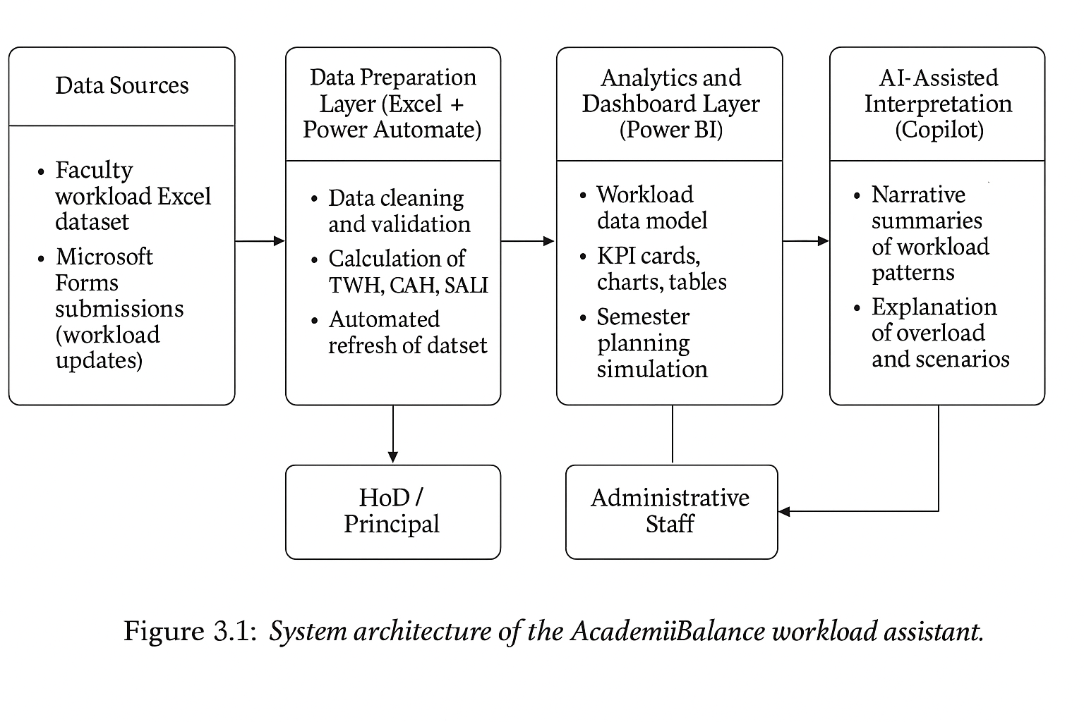
3.2 Modules / Components Used
The project methodology is organised into several functional modules:
- Module 1 – Data Ingestion and Design: Design and creation of a simulated multi-programme faculty workload dataset in Excel, including faculty attributes, course details, and raw workload hours for teaching, labs, committees, and other duties (Fitzpatrick & Mehalik, 2016; Microsoft Corporation, n.d.-a).
- Module 2 – Data Cleaning and Standardisation: Checking for consistency in faculty identifiers, programme codes, contract types, and hour allocations; correcting data types; and ensuring uniform labels for use in Power BI filters and measures (Mostert & van der Merwe, 2016; Patel & Sharma, 2024).
- Module 3 – Metric Calculation: Computation of TWH, CAH, and SALI, along with additional measures such as average workload and overload flags based on defined thresholds for balanced, overloaded, and under-loaded status (Fitzpatrick & Mehalik, 2016; Mushabe et al., 2022; Karthikeyan & Suresh, 2023).
- Module 4 -- Visual Analytics and Dashboarding: Development of the AcademiBalance Power BI dashboard, including KPI cards, comparative charts, selected faculty detail views, dialog-based inspection of individual records, and slicers for department, programme, semester, and contract type (Microsoft Corporation, n.d.-b; Patel & Sharma, 2024; Singh & Kumar, 2025).
- Module 5 – Semester Planning Simulation: Implementation of what-if parameters and scenario slicers that allow administrators to adjust course allocations and immediately see projected changes in TWH, CAH, and SALI across faculty members (Mostert & van der Merwe, 2016; Singh & Kumar, 2025).
- Module 6 – AI Integration: Use of Microsoft Copilot to generate narrative summaries of dashboard views, including explanations of overload patterns, department-wise imbalances, and the effects of simulated reallocations (Bhat & Rao, 2023; Microsoft Corporation, n.d.-c).
- Module 7 – Chatbot Integration: A chatbot interface is integrated with the AcademiBalance dashboard to support natural-language question answering. The chatbot is designed to respond to user queries related to TWH, CAH, SALI, faculty overload status, programme-wise comparisons, and dashboard interpretation. It improves accessibility by helping non-technical stakeholders interact with the system in a guided conversational format.
- Module 8 – Workflow Automation: Configuration of Microsoft Forms for workload data entry and Power Automate flows to append new records to the dataset and refresh the Power BI model, demonstrating a sustainable, low-maintenance data pipeline (Bhat & Rao, 2023; Microsoft Corporation, n.d.-a).
These modules collectively operationalise the project objectives and provide a structured pathway from raw data to actionable, AI-assisted insights (Edunet Foundation, 2026).

Statistical and Analytical Tools Used in the Project

The project uses descriptive analytics rather than advanced inferential statistics. Microsoft Excel was used for data cleaning, validation, formula-based calculations, and preparation of the simulated workload dataset. Power BI was used for data modelling, DAX-based measure creation, aggregation, KPI analysis, and interactive visualisation. The key analytical techniques applied in the project include averages, classification thresholds, workload comparisons, and derived index calculations such as Total Workload Hours (TWH), Complexity Adjusted Hours (CAH), and Student Adjusted Load Index (SALI). These tools helped convert raw faculty workload data into meaningful indicators for decision-making.

The study mainly relies on descriptive statistical tools such as mean, categorisation, comparison, aggregation, and index construction, and selectively uses basic inferential tests (one-way ANOVA and independent-samples t-test) for validation, rather than advanced techniques such as regression analysis.

3.3 Data Flow Diagram (DFD)

At the context level (DFD Level 0), the AcademiBalance system can be viewed as a single process that transforms “Faculty Workload Inputs” into “Workload Dashboards and Summaries.” Raw inputs include faculty, course, and workload details captured through Excel templates and Microsoft Forms. The process consists of data validation, metric computation, and analytical processing, while outputs include interactive dashboard views, overload classifications, and AI-generated narrative reports accessed by Heads of Department, Principals, and administrative staff (Fitzpatrick & Mehalik, 2016; Edunet Foundation, 2026).

The context-level DFD (Level 0) for AcademiBalance is shown in Figure 3.2.
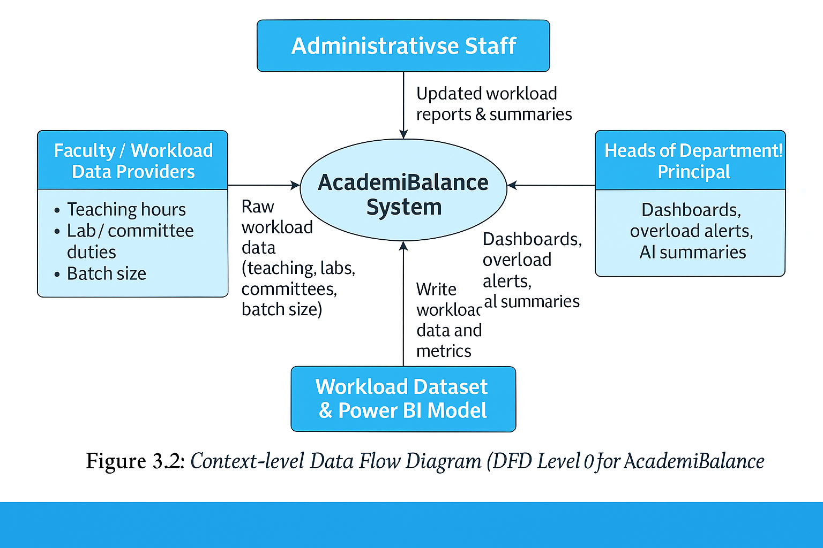

At DFD Level 1, the main process is decomposed into four key sub-processes:

- Data Loading and Validation: Importing simulated or form-submitted workload records into the Excel master file, checking for completeness and consistency, and then loading the cleaned dataset into Power BI (Microsoft Corporation, n.d.-a; Patel & Sharma, 2024).
- Data Cleaning and Transformation: Standardising identifiers, correcting data types, applying the programme complexity matrix, and computing TWH, CAH, and SALI measures required for analysis (Fitzpatrick & Mehalik, 2016; Mushabe et al., 2022).
- Analysis and AI Processing: Aggregating and filtering workload measures in Power BI, generating overload indicators, and using Copilot to create narrative summaries of key patterns and what-if scenarios (Bhat & Rao, 2023; Microsoft Corporation, n.d.-c).
- Visualisation and Report Generation: Presenting results through the AcademiBalance dashboard, including KPI cards, charts, tables, and semester planning views, and exposing these outputs to decision-makers via a user-friendly interface (Microsoft Corporation, n.d.-b; Singh & Kumar, 2025).
The Level-1 Data Flow Diagram for AcademiBalance, showing these processes and data stores, is presented in Figure 3.3.
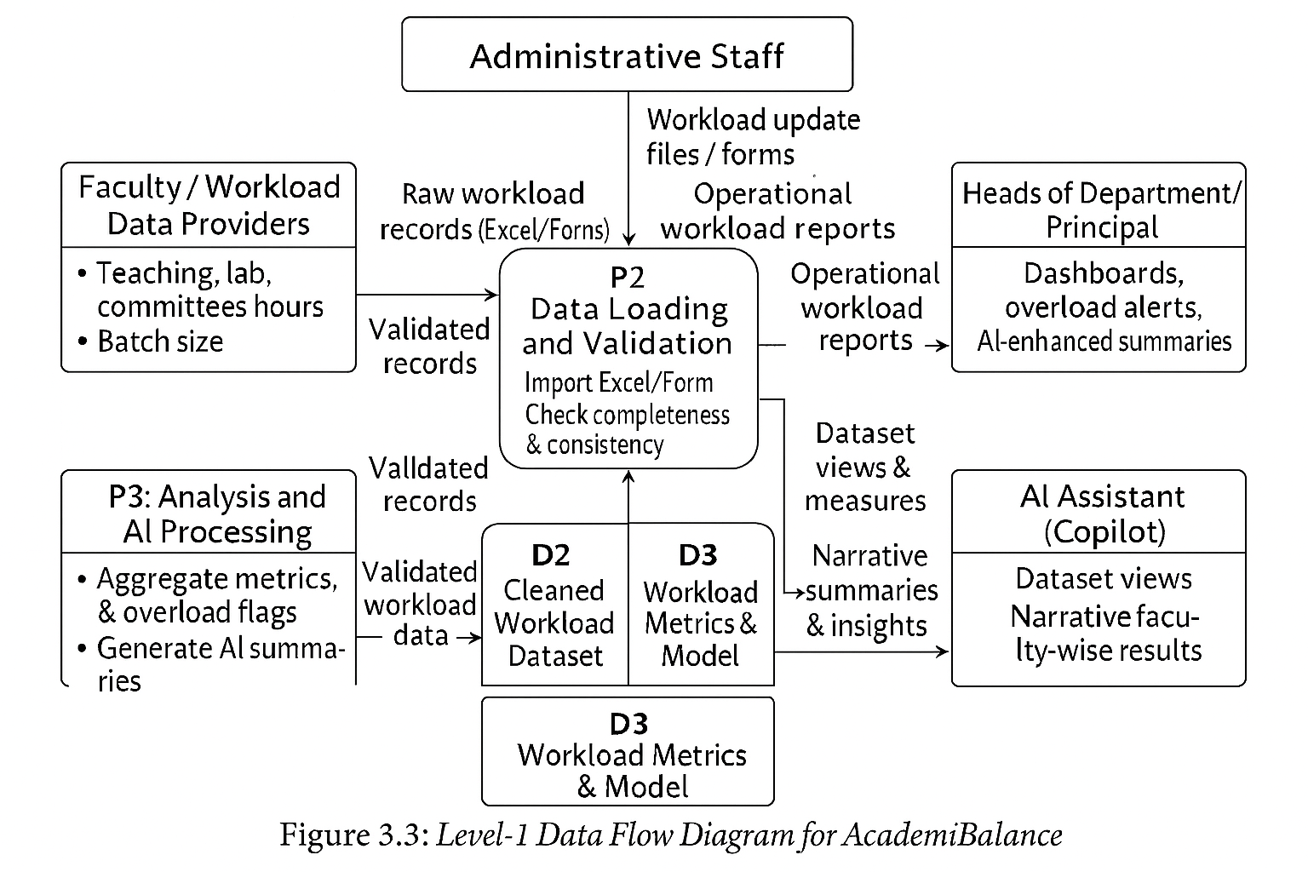
Data stores in this diagram include the Excel workload dataset, the Power BI data model, and archived form responses, while external entities consist of faculty (as data subjects) and administrators (as system users). This logical flow aligns with best practices in workload modelling and BI-driven decision support (Mostert & van der Merwe, 2016; Patel & Sharma, 2024).

In the Level 1 data flow, the processed workload data not only feeds the dashboard visuals and AI-generated summaries but also supports the chatbot interaction layer. User queries submitted through the chatbot are interpreted against the same workload metrics and dashboard logic, and the output is returned as natural-language responses. This makes the system capable of both visual and conversational delivery of insights.

3.4 Advantages

The proposed methodology offers several advantages over traditional workload management practices. By explicitly modelling TWH, CAH, and SALI, the system moves beyond simple contact-hour counting and provides a more realistic representation of faculty effort that incorporates programme complexity and student batch size (Fitzpatrick & Mehalik, 2016; Mushabe et al., 2022). This supports more equitable workload allocation and helps institutions identify hidden imbalances that might otherwise remain obscured in conventional statements (Karthikeyan & Suresh, 2023).

From a usability perspective, implementing the model in Power BI with AI-assisted narratives makes the outputs accessible to non-technical stakeholders who may not be comfortable interpreting raw tables or formulas (Patel & Sharma, 2024; Bhat & Rao, 2023). The use of Excel, Power BI, Forms, and Power Automate ensures that the solution is built on tools that many colleges already possess, reducing barriers to adoption (Microsoft Corporation, n.d.-a; Microsoft Corporation, n.d.-b). The semester planning simulation module further transforms the dashboard from a purely descriptive tool into an active decision-support system that encourages proactive, scenario-based planning rather than reactive reporting (Mostert & van der Merwe, 2016; Singh & Kumar, 2025).

A further advantage of the system is improved usability through conversational interaction. Instead of depending only on charts, tables, and filters, users can ask direct questions and receive immediate explanations, which increases the accessibility of the workload analytics for non-technical academic administrators.

3.5 Requirement Specification

Hardware Requirements

The hardware requirements for implementing AcademiBalance are modest and align with typical college-level infrastructure. A standard desktop or laptop with at least an Intel Core i3 processor (or equivalent), 4 GB of RAM (8 GB recommended), and sufficient free storage to handle Power BI models and Excel files is adequate for development and routine use (Edunet Foundation, 2026). A display resolution of 1366 × 768 or higher is recommended to comfortably view dashboards and forms, and a stable internet connection is required for access to cloud-based services such as Copilot, Forms, and Power Automate (Microsoft Corporation, n.d.-b; Microsoft Corporation, n.d.-c).

Software Requirements

On the software side, the project assumes access to:
- A modern operating system such as Windows 10 or 11;
- Microsoft Excel (preferably as part of Microsoft 365) with support for advanced formulas and data cleaning features;
- Microsoft Power BI Desktop for modelling and visualisation;
- Microsoft Forms and Power Automate for data collection and workflow automation; and
- Microsoft Copilot or an equivalent AI assistant integrated with the Microsoft ecosystem (Microsoft Corporation, n.d.-a; Microsoft Corporation, n.d.-b; Microsoft Corporation, n.d.-c).
- A chatbot platform such as Microsoft Copilot Studio, Power Virtual Agents, or an equivalent conversational AI interface for question-based interaction with workload insights.
These tools together provide a complete environment for data preparation, analytics, AI-assisted summarisation, and automated refresh, in line with the goals of the AICW Fellowship Program (Edunet Foundation, 2026; Bhat & Rao, 2023).

CHAPTER 4
Implementation and Results
This chapter explains how the AcademiBalance model was implemented on the 70-faculty dataset and presents the main workload patterns obtained from the derived metrics Total Workload Hours (TWH), Complexity-Adjusted Hours (CAH), and Student-Adjusted Load Index (SALI). The implementation followed the methodology described earlier, moving from data preparation and cleaning in Excel to analytical visualisation and AI-assisted interpretation aligned with the AICW fellowship context (Edunet Foundation, 2026; Fitzpatrick & Mehalik, 2016).

In addition to the visualisation components, AcademiBalance includes a chatbot feature that allows users to ask workload-related questions in natural language. This feature extends the system from a dashboard-only view into a more interactive decision-support assistant by enabling question-based access to the same workload insights represented in the charts, filters, and faculty detail views.

4.1 Data Cleaning Results

The original Excel file, “AcademiBalance_70_Faculty_Workload_Dataset”, contained 70 records, each describing the workload of a faculty member for a specific department, programme, and semester. The dataset included faculty identifiers, department and programme details, semester and contract type, as well as detailed workload components such as TeachingHours, LabHours, CommitteeHours, OtherDutiesHours, BatchSize, ProgrammeComplexityCoefficient, and three derived metric fields: TotalWorkloadHours, ComplexityAdjustedHours, and StudentAdjustedLoadIndex. This structure is consistent with recommendations for multidimensional workload models that separate raw components from derived effort indicators (Fitzpatrick & Mehalik, 2016; Mushabe et al., 2022).

During the data cleaning phase, obviously empty columns (labelled “Unnamed” in the worksheet) were removed, and programme and contract labels were checked for consistency. All hour-related fields and metric columns were converted or confirmed as numeric so that aggregation and classification operations could be performed reliably. This ensured that the dataset could support the calculation of overall averages, programme-wise patterns, and overload classifications required by the AcademiBalance framework (Mostert & van der Merwe, 2016).

Table 4.1 summarises the structure of the cleaned dataset.

Table 4.1: Cleaned Faculty Workload Dataset Structure
Field Category | Fields in Dataset
Faculty identification | FacultyID, FacultyName, Department, Programme, Semester
Contract information | ContractType (Regular, Visiting)
Workload components | TeachingHours, LabHours, CommitteeHours, OtherDutiesHours
Student information | BatchSize
Complexity information | ProgrammeComplexityCoefficient
Derived metrics | TotalWorkloadHours (TWH), ComplexityAdjustedHours (CAH), StudentAdjustedLoadIndex (SALI)

Using this cleaned dataset, overall workload statistics were computed. The averages of TWH, CAH, and SALI provide a snapshot of the typical workload experienced by faculty in the simulated college environment (Fitzpatrick & Mehalik, 2016; Mushabe et al., 2022).

Table 4.2: Overall Workload Metrics (n = 70)

Metric | Value (from dataset)
Number of faculty records | 70
Average Total Workload Hours (TWH) | 17.17 hours/week
Average Complexity-Adjusted Hours (CAH) | 20.74 hours/week
Average Student-Adjusted Load Index (SALI) | 747.12

On average, each faculty member in the dataset carries about 17 hours of recorded workload per week, which increases to approximately 21 hours when adjusted for programme complexity, and corresponds to an average SALI of around 747 once student batch size and complexity are taken into account. These results are consistent with earlier findings that complexity-aware models typically show higher effective loads than raw contact-hour figures alone (Fitzpatrick & Mehalik, 2016; Karthikeyan & Suresh, 2023).

A portion of the cleaned faculty workload dataset, showing the derived TWH, CAH and SALI fields, is displayed in Figure 4.1.

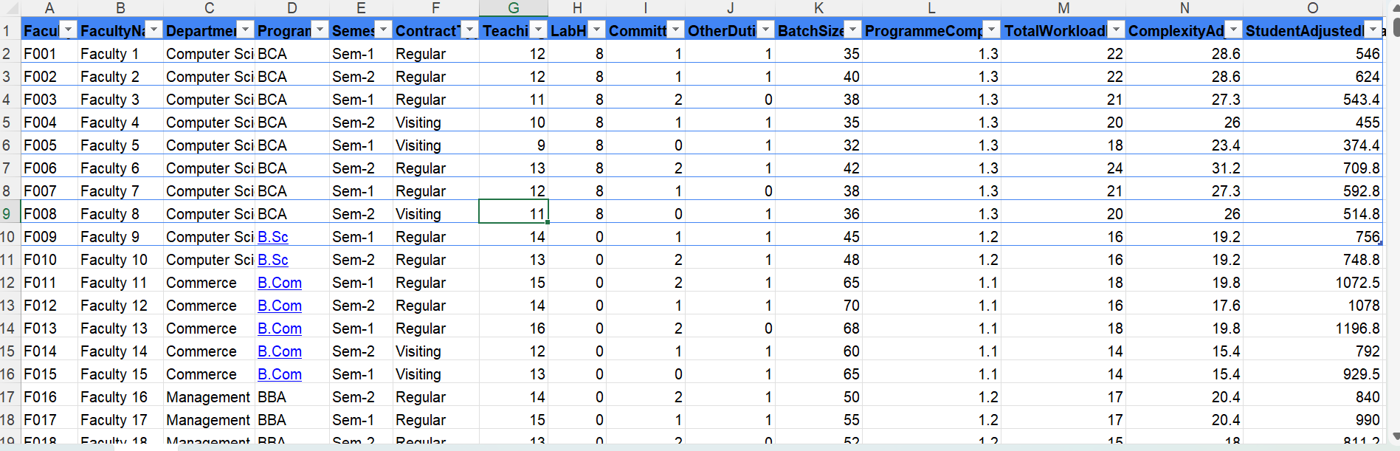
Figure 4.1: Cleaned faculty workload dataset with Total Workload Hours (TWH), Complexity‑Adjusted Hours (CAH), and Student‑Adjusted Load Index (SALI).

4.2 Visualisation Output Results

To understand how workload is distributed across different academic programmes, programme-wise averages of TWH, CAH, and SALI were computed for BCA, B.Sc, B.Com, BBA, BBA Aviation, and Languages. This aligns with literature emphasising the need to analyse workload at multiple aggregation levels, including programme and department (Mostert & van der Merwe, 2016; Mushabe et al., 2022).

The main AcademiBalance Power BI dashboard, built on the 70-faculty dataset, is shown in Figure 4.2

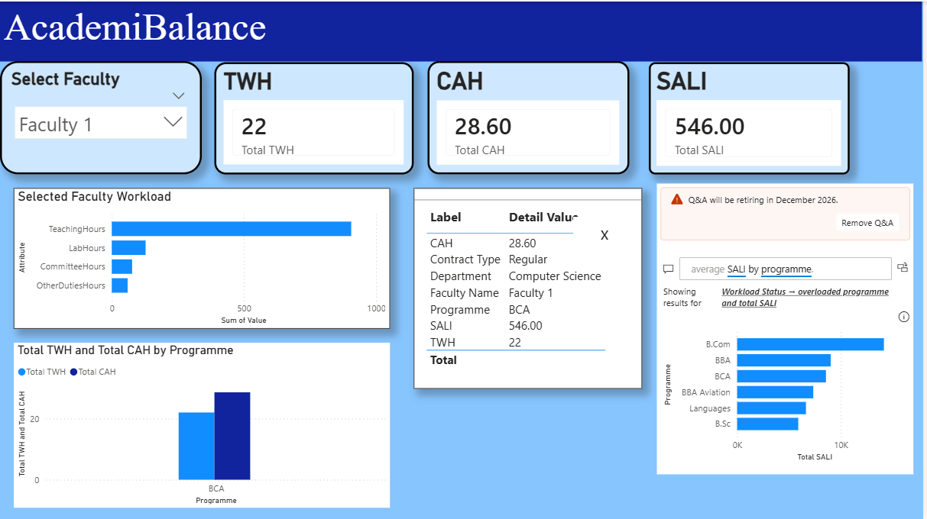
Figure 4.2: AcademiBalance Power BI dashboard showing key workload indicators and filters

Table 4.3: Programme-Wise Average Adjusted Workload

Programme | Avg TWH (hrs) | Avg CAH (hrs) | Avg SALI
BCA | 21.00 | 27.30 | 535.00
B.Sc | 16.00 | 19.20 | 737.00
B.Com | 16.00 | 17.60 | 943.00
BBA | 15.00 | 18.00 | 752.00
BBA Aviation | 15.80 | 20.50 | 816.00
Languages | 16.00 | 16.00 | 664.00

Figure 4.3: Average Student-Adjusted Load Index (SALI) by programme
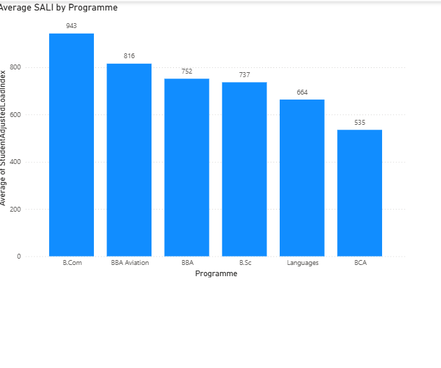

The programme-wise analysis shows that B.Com has the highest average SALI, reflecting large batch sizes combined with moderate complexity, while BBA and BBA Aviation also exhibit relatively high adjusted loads due to management-oriented curricula with moderate to high complexity coefficients (Fitzpatrick & Mehalik, 2016; Karthikeyan & Suresh, 2023). In contrast, BCA shows the highest average CAH because of intensive laboratory components and higher complexity coefficients, even though its average SALI remains lower than that of B.Com due to smaller batch sizes (Mushabe et al., 2022). Languages shows moderate TWH and SALI values, consistent with lower complexity coefficients and relatively smaller batches.

To illustrate how these patterns appear at the individual level, a sample of faculty records was extracted from the dataset, highlighting overloaded, balanced, and underloaded cases based on SALI thresholds. Consistent with the conceptual model adopted in the project, SALI values above 900 are treated as overloaded, values between 600 and 900 as balanced, and values below 600 as underloaded. The dashboard supports this interpretation through faculty selection, after which a dialog box presents the selected faculty member’s workload measures, programme information, contract type, and status in a focused view. (Karthikeyan & Suresh, 2023; Mushabe et al., 2022).

Table 4.4: Sample Faculty Workload Classification Records

FacultyID | Faculty Name | Department | Programme | ContractType | TWH | CAH | SALI | Status*
F011 | Faculty 11 | Commerce | B.Com | Regular | 18.0 | 19.8 | 1072.5 | Overloaded
F012 | Faculty 12 | Commerce | B.Com | Regular | 16.0 | 17.6 | 1078.0 | Overloaded
F013 | Faculty 13 | Commerce | B.Com | Regular | 18.0 | 19.8 | 1196.8 | Overloaded
F017 | Faculty 17 | Management | BBA | Regular | 17.0 | 20.4 | 990.0 | Overloaded
F021 | Faculty 21 | Management | BBA Aviation | Regular | 18.0 | 23.4 | 936.0 | Overloaded
F027 | Faculty 27 | Languages | Languages | Regular | 19.0 | 19.0 | 880.0 | Balanced
F029 | Faculty 29 | Languages | Languages | Visiting | 13.0 | 13.0 | 540.0 | Under-loaded
*Status rule: SALI > 900 = Overloaded; 600–900 = Balanced; < 600 = Under-loaded.

Table 4.4 demonstrates that regular B.Com and BBA/BBA Aviation faculty are frequently classified as overloaded due to the combination of high teaching hours, complex programmes, and large batch sizes, whereas visiting Languages faculty can fall into the under-loaded category when they handle fewer hours and smaller batches (Fitzpatrick & Mehalik, 2016; Karthikeyan & Suresh, 2023). These examples illustrate how adjusted metrics such as CAH and SALI reveal inequities that would not be apparent from raw contact-hour counts alone, supporting the argument for complexity-aware workload models (Mostert & van der Merwe, 2016; Mushabe et al., 2022).

In the actual implementation, these results are visualised through the AcademiBalance dashboard in Power BI using KPI cards, bar charts, slicers, and interactive faculty-level inspection. For example, a bar chart of average SALI by programme derived from Table 4.3 helps Heads of Department identify overloaded programmes, while faculty selection opens a detail dialog showing the corresponding TWH, CAH, SALI, and status for individual-level review. This combination supports both summary-level interpretation and focused examination of specific faculty records(Patel & Sharma, 2024; Singh & Kumar, 2025).
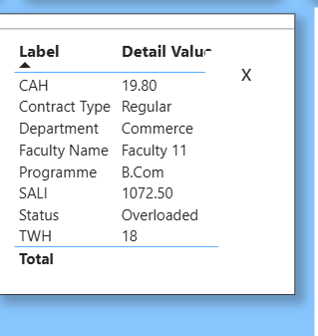
Figure 4.4: Selected faculty detail dialog showing workload metrics and status4.3 AI Tool Integration Results

4.3 AI Tool Integration Results

The final part of the implementation involves integrating AI-assisted narrative support on top of the same dataset and visual outputs. In line with recent work on AI-enabled administration, an assistant such as Microsoft Copilot can be used to generate natural-language explanations of the patterns observed in the AcademiBalance dashboard (Bhat & Rao, 2023).

For example, prompts can be designed to ask the AI to “summarise which programmes have the highest average SALI and why”, “identify overloaded faculty and explain the contributing factors”, or “compare workload profiles of regular and visiting faculty across departments”.

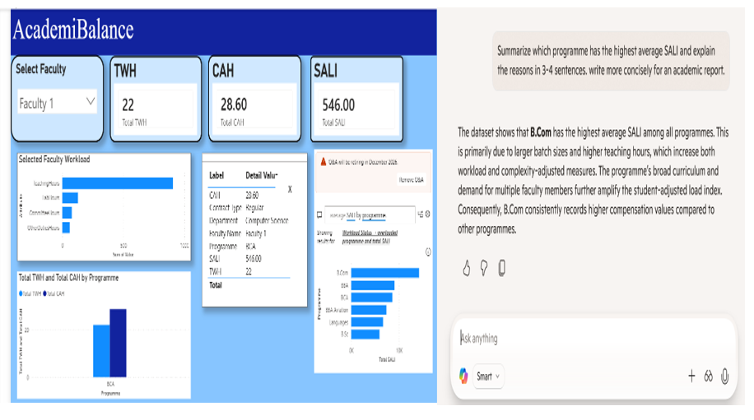
Figure 4.5: Example AI-generated narrative explaining workload patterns from the AcademiBalance dashboard

Such AI-generated narratives help non-technical stakeholders interpret the tables and charts presented in Sections 4.1 and 4.2, reducing dependence on manual analysis and specialist skills (Bhat & Rao, 2023; Microsoft Corporation, n.d.-c). Within the AICW fellowship framework, this integration demonstrates how descriptive and diagnostic analytics built in Excel and Power BI can be complemented by AI-driven explanation to create an accessible, decision-support assistant for faculty workload planning (Edunet Foundation, 2026; Patel & Sharma, 2024).

In the full report, screenshots of the main dashboard view, programme-wise SALI chart, selected faculty detail dialog, and an example AI-generated summary can be included as supporting figures for Chapter 4, providing visual evidence of how the AcademiBalance system behaves with the 70-faculty dataset.

4.4 Chatbot Integration Results
As part of the AcademiBalance implementation, a chatbot interface was introduced to support conversational analysis of faculty workload data. The chatbot allows users to ask natural-language questions such as which programme has the highest SALI, which faculty members are overloaded, what the meaning of CAH is, and how workload differs across departments. The chatbot responses are based on the same metrics and logic used in the Power BI dashboard, thereby ensuring consistency between visual outputs and conversational explanations. This feature improves the usability of the system by reducing dependence on manual filter selection and chart interpretation. It is especially useful for non-technical users who prefer guided question-and-answer interaction over direct dashboard exploration. Alongside this, the dashboard also allows record-level inspection through a selected faculty detail dialog, where the workload measures and status of the chosen faculty member are presented in a focused format. In the overall interface design, the chatbot complements the visual analytics and detail views rather than replacing them. An example chatbot interaction is shown in Figure 4.6 below.

Figure 4.6 Chatbot answering workload-related questions in the AcademiBalance system
4.5 Statistical Validation of Workload Metrics
To statistically validate whether the proposed workload indicators capture meaningful differences across programmes and contract types, inferential tests were performed on the Student Adjusted Load Index (SALI) and Complexity Adjusted Hours (CAH) using the simulated dataset of 70 faculty–course records. The analysis focused on (i) differences across programmes and (ii) differences between regular and visiting faculty.
4.5.1 One-Way ANOVA: SALI by Programme
A one-way ANOVA was conducted to test whether mean SALI differs significantly across the six programmes (BCA, B.Sc, B.Com, BBA, BBA Aviation, and Languages). The null hypothesis stated that there is no difference in mean SALI across programmes, while the alternative hypothesis stated that at least one programme has a different mean SALI.
The results show a statistically significant effect of programme on SALI, $F(5,64)=21.19$, $p<0.001$. The corresponding eta-squared effect size $η^{2}=0.62$ indicates that approximately 62% of the variance in SALI is explained by programme membership, which represents a large practical effect in the context of faculty workload modelling. This confirms that the SALI measure is sensitive to programme-level differences in complexity and student load, and that treating all teaching assignments as equivalent would mask substantial variation in adjusted workload across programmes.
4.5.2 One-Way ANOVA: CAH by Programme
A similar one-way ANOVA was performed on Complexity Adjusted Hours (CAH) to examine whether programme assignment significantly influences complexity-weighted workload. The null hypothesis again assumed equal mean CAH across programmes, while the alternative posited at least one difference.
The analysis yielded a highly significant result, $F(5,64)=49.33$, $p<0.001$. The eta-squared effect size for this model was $η^{2}=0.79$, suggesting that nearly 79% of the variability in CAH is attributable to differences between programmes. This very large effect provides strong evidence that the programme complexity coefficients embedded in the AcademiBalance model meaningfully differentiate faculty workload and that CAH is an effective indicator for capturing programme-driven workload variation.
4.5.3 Independent t-Test: SALI by Contract Type (Regular vs. Visiting)
To assess whether contract type is associated with systematic differences in adjusted workload, an independent-samples t-test (Welch’s t-test) was conducted comparing SALI for regular and visiting faculty. The null hypothesis stated that there is no difference in mean SALI between regular and visiting faculty, whereas the alternative hypothesis stated that a difference exists.
Regular faculty recorded a higher mean SALI (mean = 799.26) than visiting faculty (mean = 625.37). The difference was statistically significant, $t=4.48$, $p<0.001$, indicating that regular faculty in the simulated dataset carry a substantially higher student-adjusted workload than visiting staff. The corresponding Cohen’s $d=1.08$ reflects a large effect size, reinforcing the interpretation that contract type is strongly associated with differences in adjusted workload within the AcademiBalance model.
4.5.4 Interpretation and Implications
Taken together, the ANOVA and t-test results provide robust statistical support for the validity of the AcademiBalance workload metrics. The strong programme effects on both SALI and CAH confirm that incorporating programme complexity and student batch size yields meaningful differentiation in workload that would be invisible in simple contact-hour summaries. The significant and practically large difference in SALI between regular and visiting faculty further demonstrates that the model is capable of highlighting structural workload imbalances across contract types, which can inform more transparent and equitable allocation decisions in semester planning.
Table 4.5 Statistical Test Results for Workload Metrics
Test | Dependent Variable | Grouping Variable | Test Statistic | p-value | Effect Size | Interpretation
One-way ANOVA | Student Adjusted Load Index (SALI) | Programme (6 levels: BCA, B.Sc, B.Com, BBA, BBA Aviation, Languages) | $$F(5,64)=21.19$$ | < 0.001 | $η^{2}=0.62$(large effect) | Mean SALI differs significantly across programmes; programme explains a substantial proportion of variance in adjusted workload.
One-way ANOVA | Complexity Adjusted Hours (CAH) | Programme (6 levels: BCA, B.Sc, B.Com, BBA, BBA Aviation, Languages) | $$F(5,64)=49.33$$ | < 0.001 | $η^{2}=0.79$(very large effect) | Programme strongly influences CAH; complexity coefficients meaningfully differentiate workload between programmes.
Independent-samples t-test | Student Adjusted Load Index (SALI) | Contract Type (Regular vs. Visiting) | $$t=4.48$$ | < 0.001 | $d=1.08$(large effect) | Regular faculty have significantly higher mean SALI than visiting faculty, indicating higher adjusted workload for regular staff.

CHAPTER 5
Discussion and Conclusion
The first key finding from the AcademiBalance implementation is that complexity‑ and student‑adjusted workload metrics reveal patterns that are not visible when relying only on raw contact hours. When Total Workload Hours (TWH) are adjusted using programme complexity coefficients to obtain Complexity‑Adjusted Hours (CAH), and further combined with batch size to produce the Student‑Adjusted Load Index (SALI), several faculty members who appear similar on TWH are shown to carry significantly different effective workloads (Fitzpatrick & Mehalik, 2016; Mushabe et al., 2022). This confirms earlier arguments that ignoring complexity and student volume can conceal important inequities in workload allocation (Karthikeyan & Suresh, 2023).

A second key finding is that, even within this simulated 70‑faculty dataset, there is a clear spread of faculty across overloaded, balanced, and under‑loaded categories when SALI is used as the classification basis. Using the thresholds adopted in this project (SALI > 900 as overloaded, 600–900 as balanced, and < 600 as under‑loaded), the distribution of faculty is as shown in Table 5.1.

The inferential statistical analysis provides additional support for the robustness of the AcademiBalance workload model. One‑way ANOVA results show that both the Student Adjusted Load Index (SALI) and Complexity Adjusted Hours (CAH) vary significantly across programmes with large effect sizes, confirming that programme complexity and student batch size are crucial determinants of faculty workload. The significant difference in SALI between regular and visiting faculty, with a large effect size, further highlights how the model can reveal structural workload imbalances across contract types that need to be considered in future semester planning and workload negotiations.

Table 5.1: SALI-Based Workload Classification (n = 37*)
Category | SALI Range | Count | Percentage of Faculty
Under-loaded | < 600 | 7 | 18.9%
Balanced | 600–900 | 23 | 62.2%
Overloaded | > 900 | 7 | 18.9%
*Based on the subset of faculty rows from the dataset for which SALI values were used in this
analysis.
These figures indicate that nearly one-fifth of the sampled faculty are overloaded according to the SALI metric, another one-fifth are under-loaded, and around three-fifths fall into a balanced band. This kind of tripartite classification provides a practical basis for Heads of Department to prioritise interventions—such as reallocating courses from overloaded to balanced or under-loaded faculty—before timetables are finalised (Mostert & van der Merwe, 2016; Mushabe et al., 2022). It also illustrates how the AcademiBalance model can support evidence-based dialogue about workload fairness in line with findings from previous empirical studies on workload and performance (Karthikeyan & Suresh, 2023).

A third important finding relates to programme-level patterns: B.Com, BBA, and BBA Aviation show higher average SALI values than Languages, reflecting larger batch sizes and higher complexity in commerce and management programmes. This mirrors the faculty-level examples in Chapter 4, where regular B.Com and BBA/BBA Aviation faculty frequently appear in the overloaded category, whereas some visiting Languages faculty fall into the under-loaded category. Together, these programme-wise and individual-level patterns demonstrate that the AcademiBalance model successfully operationalises the complexity-aware workload concepts discussed in the literature and makes them accessible through structured metrics and visualisation (Fitzpatrick & Mehalik, 2016; Patel & Sharma, 2024; Singh & Kumar, 2025).

5.2 Project Links

To support evaluation and reuse, the project is intended to provide the following artefacts:
- A GitHub repository containing the simulated Excel dataset, Power BI report file (.pbix), and documentation of the complexity matrix, measures, and workflow configuration, available at: https://github.com/Priya051188/AcademiBalance-Faculty-Workload.git (Edunet Foundation, 2026).
- A short video demonstration of the AcademiBalance dashboard and semester planning simulation module, illustrating how Heads of Department can interact with the visuals and AI summaries during workload planning discussions, is available at: https://drive.google.com/file/d/17Lm-Oe90wvE2gw6Prff3xY_ETZSFOren/view?usp=sharing
- A shared Power BI dashboard hosted in the Power BI Service, accessible to authorised evaluators via an organisational sharing link, allowing them to inspect the design and layout of the AcademiBalance visuals:https://app.powerbi.com/groups/me/reports/4c1ba413-431c-4c8a-a251-f00123c7acf8?ctid=962ebf20-6f89-452c-9996-ff1428f7a78e&pbi_source=linkShare
These links and artefacts will allow other educators and administrators to replicate, adapt, or extend the AcademiBalance concept for their own institutional contexts (Bhat & Rao, 2023; Edunet Foundation, 2026).

5.3 Limitations

The project has several limitations that should be acknowledged. First, the dataset is fully simulated, based on realistic but assumed values for faculty workloads, batch sizes, and programme complexity; it does not incorporate live institutional data (Edunet Foundation, 2026). While this is appropriate for a proof-of-concept and avoids privacy concerns, it means that the specific patterns observed in the dashboard cannot be interpreted as findings about any particular college (Fitzpatrick & Mehalik, 2016).

Second, the complexity coefficients and overload thresholds are defined using judgement and simple distribution-based heuristics rather than through extensive empirical calibration, which would require longitudinal data and organisational consensus (Mostert & van der Merwe, 2016; Mushabe et al., 2022).

Third, the implementation focuses on descriptive and diagnostic analytics, without incorporating predictive models or advanced optimisation techniques for automatically suggesting optimal allocations (Patel & Sharma, 2024; Singh & Kumar, 2025). Finally, the solution is built around the Microsoft ecosystem; institutions without access to Excel, Power BI, Forms, Power Automate, or Copilot would need to adapt the design to alternative platforms, which may require additional technical expertise (Microsoft Corporation, n.d.-a; Microsoft Corporation, n.d.-b). These limitations frame the project as a robust prototype rather than as a fully production-ready enterprise system.

5.4 Future Work
Future work could extend AcademiBalance in several directions. One avenue is to deploy the model with real institutional data under appropriate governance and ethics frameworks, enabling calibration of complexity coefficients and overload thresholds against actual faculty experiences and organisational norms (Karthikeyan & Suresh, 2023; Mushabe et al., 2022). Another direction is to incorporate predictive analytics, such as algorithms to forecast overload risk under different enrolment scenarios or to suggest alternative allocations that minimise imbalance subject to constraints (Mostert & van der Merwe, 2016; Singh & Kumar, 2025).

The system could also be expanded into a web-based or Power Apps front-end, allowing Heads of Department and administrators to interact with workload planning tools through a more tailored interface while still leveraging the existing Power BI model and workflows (Microsoft Corporation, n.d.-b; Bhat & Rao, 2023). In addition, developing a standardised prompt library for Copilot that covers common workload analysis questions and reporting tasks would improve consistency and reusability of AI-generated narratives across departments and institutions (Microsoft Corporation, n.d.-c). Over time, such enhancements could turn AcademiBalance from a fellowship project into a scalable institutional workload management solution (Edunet Foundation, 2026).

Future work may extend the chatbot to connect directly to live institutional datasets, enabling dynamic question answering, personalised workload recommendations, and deeper scenario-based planning support. The chatbot can also be expanded to provide department-specific summaries, explain visualisations automatically, and assist administrators during timetable planning and workload review meetings.

5.5 Conclusion

AcademiBalance set out to demonstrate how an AI-driven faculty workload and time allocation assistant can be built using familiar tools such as Excel, Power BI, Microsoft Forms, Power Automate, and Copilot within the AICW fellowship context (Edunet Foundation, 2026; Microsoft Corporation, n.d.-a). By designing a structured workload dataset and introducing the metrics of Total Workload Hours, Complexity-Adjusted Hours, and Student-Adjusted Load Index, the project moved beyond traditional contact-hour counting to capture key drivers of faculty effort such as programme complexity and student volume (Fitzpatrick & Mehalik, 2016; Mushabe et al., 2022). The resulting dashboard and simulation module showed how interactive visualisation can improve transparency and support proactive, scenario-based workload planning (Mostert & van der Merwe, 2016; Patel & Sharma, 2024).

The integration of AI-generated narratives through Copilot further illustrated how analytics can be made accessible to non-technical stakeholders, enabling clearer communication of workload patterns and planning decisions (Bhat & Rao, 2023; Microsoft Corporation, n.d.-c). Although the project operates with simulated data and within defined scope boundaries, it provides a concrete template that institutions can adapt and extend to their own contexts. Overall, AcademiBalance contributes both a methodological example and a practical artefact that align with the goals of the AICW Fellowship: to develop meaningful, AI-enabled solutions to contemporary challenges in education and administration while strengthening participants’ skills in data analytics and business intelligence (Edunet Foundation, 2026).

The chatbot further strengthens the practical value of AcademiBalance by making workload analytics easier to access through conversational interaction. While the dashboard provides rich visual evidence through KPI cards, charts, tables, and slicers, the chatbot offers a simpler front-end for asking direct questions about workload fairness, overload status, and programme-level differences. This combination of dashboard analytics and chatbot support improves the usefulness of the system for a wider range of institutional users.
REFERENCES

- Bhat, J., & Rao, S. Automating Higher Education Administrative Processes with AI. International Journal of Emerging Technologies in Computational and Information Sciences, 5(4), 33–41, 2023.ijetcsit
- Edunet Foundation. AICW Fellowship Program Guidelines. 2026.AICW_Faculty_Workload_Synopsis_Dr_PriyaA.docx
- Fitzpatrick, L. R., & Mehalik, M. M. A Novel Mathematical Model for Determining Faculty Workload. American Journal of Pharmaceutical Education, 80(9), 155, 2016.pmc.ncbi.nlm.nih
- Karthikeyan, R., & Suresh, P. Impact of Workload and Role Expectations on Faculty Performance in Higher Education Institutions in Erode District. Kesit Akademi Dergisi, 9(40), 120–135, 2023.kuey
- Microsoft Corporation. Microsoft Excel Documentation. (n.d.-a).AICW_Faculty_Workload_Synopsis_Dr_PriyaA.docx
- Microsoft Corporation. Power BI Documentation. (n.d.-b).AICW_Faculty_Workload_Synopsis_Dr_PriyaA.docx
- Microsoft Corporation. Microsoft Copilot — AI-Powered Productivity. (n.d.-c).AICW_Faculty_Workload_Synopsis_Dr_PriyaA.docx
- Mostert, W., & van der Merwe, A. A Model for Management of Workload and Performance in a University of Technology. Risk Governance & Control: Financial Markets & Institutions, 6(1), 41–52, 2016.virtusinterpress
- Mushabe, C., et al. Reconceptualizing Faculty Workload as a Measure of Performance in Higher Education. Studies in Educational Evaluation, 75, 101180, 2022.sciencedirect
- Patel, S., & Sharma, A. A Power BI-Based College Analysis Dashboard. International Journal of Trend in Scientific Research and Development, 8(2), 112–118, 2024.ijtsrd
- Singh, P., & Kumar, R. Academic Performance Monitoring System Using Power BI. International Research Journal of Modernization in Engineering, Technology and Science, 7(10), 2500–2507, 2025.irjmets
- Kaggle Inc. Open Datasets. (n.d.).AICW_Faculty_Workload_Synopsis_Dr_PriyaA.docx

APPENDICES
Include any additional information that supports the project but is too detailed for the main chapters. This may include:
Appendix A — Sample Dataset
provides a sample of the cleaned 70-faculty workload dataset used in the AcademiBalance project.
Appendix B — Key Excel Formulas / DAX Measures Used
This appendix lists representative Excel formulas and DAX measures used to compute TWH, CAH, SALI, and status fields in AcademiBalance.
- =SUM(TeachingHours, LabHours, CommitteeHours, OtherDutiesHours) — used to compute Total Workload Hours (TWH) in Excel.
- =TWH * ProgrammeComplexityCoefficient — used to compute Complexity Adjusted Hours (CAH).
- =TeachingHours * ProgrammeComplexityCoefficient * BatchSize — used to compute SALI in Excel before loading into Power BI.
- DAX: Total TWH = SUM(FacultyWorkload[TotalWorkloadHours]) — used for dashboard KPI card.
- DAX: Avg SALI = AVERAGE(FacultyWorkload[StudentAdjustedLoadIndex]) — used in SALI by Programme chart.
- DAX (Status):
Status = IF([Avg SALI] > 900, "Overloaded", IF([Avg SALI] < 600, "Underloaded", "Balanced")) — used to classify faculty into three workload bands.
Appendix C — AI Prompts Used
List the key prompts you used with Copilot or AI Chatbot during the project:
- Prompt 1: "Summarize this sales data and identify the top 5 performing regions."
- Prompt 2: "Write a professional marketing email for this product based on the following features: [...]"
- Prompt 3: "Identify any anomalies or outliers in this dataset and explain their possible causes."
- [Add the prompts specific to your project.]
Appendix D — Screenshot Gallery
Figure D.1 Cleaned faculty workload dataset in Excel.
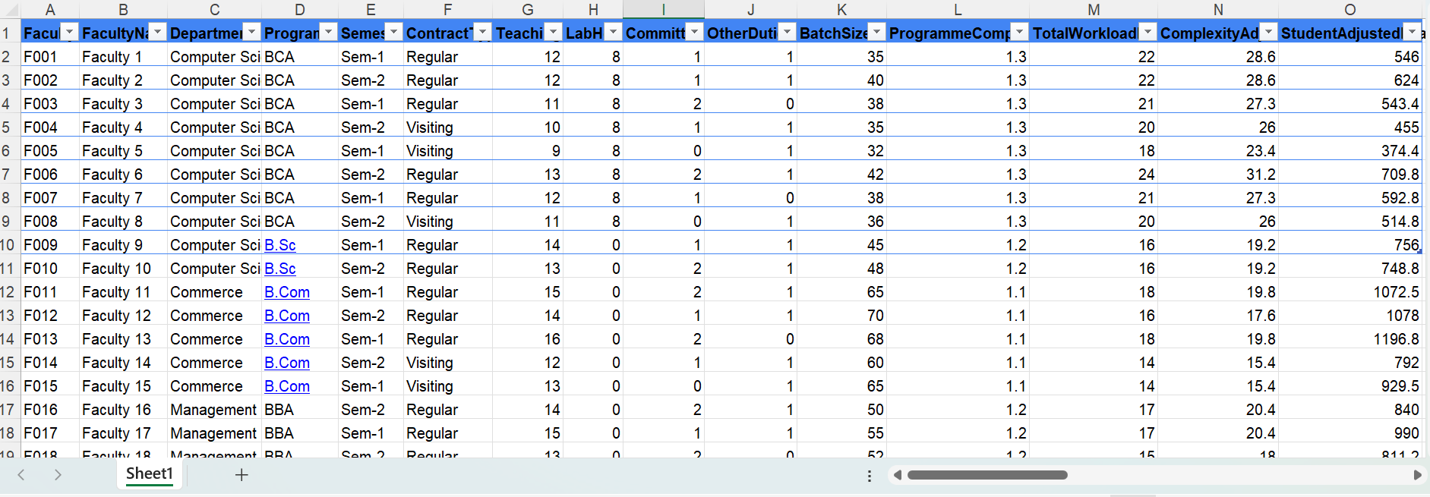

Figure D.2 AcademiBalance Power BI dashboard with SALI by programme.


Figure D.3 – Selected faculty detail dialog showing workload metrics and status in the AcademiBalance dashboard



Figure D.4 – Example AI-generated narrative explaining workload patterns from the AcademiBalance dashboard


